Building Level & Space Numbering Standard

Version Date: May 2019

Contents

Contents 1

Chapter 1: Overview of Space Numbering, Space Naming and Door Numbering 2

Introduction 2

Request for Approval Process: 3

Contact Information: 4

Chapter 2: Building Level and Space Numbering 5

Introduction 5

Definitions 6

Numbering Conventions 8

Space Numbering 14

Building Support Items and Other Assets Numbering 21

Do’s and Don’ts 26

Conflicts and Special Cases 27

References 28

Chapter 2: Space Naming and Room Data Categorization 29

Introduction 29

Definitions 30

Space Naming Table 38

Chapter 3: Door Numbering 44

Introduction 44

Definitions 45

Numbering Convention 46

Door Tags 47

Door Tag Placement 48

Appendix 1: Space Numbering Review and Approval Checklist 49

Appendix 2: Revit Alias Space Numbering Protocol 50

Chapter 1: Overview of Space Numbering, Space Naming and Door Numbering

## Introduction

The purpose of this chapter is to define the San Francisco International Airport (SFO or Airport) Building Level and Space Numbering Standard (and the definition of what constitutes a space), Space Naming Standard (and the related attributes and data critical to understanding the use of a space), and Door Numbering Standard. The Standards shall be utilized to ensure continuity of the Airport’s terminal and non-terminal space and to help maintain the integrity of the Airport’s spatial data infrastructure and design standards.

The Airport integrated spatial data scheme allows multiple databases and systems to be integrated through a common attribute. Since Computer Aided Design (CAD) drawings, Geographic Information System (GIS), and/or Building Information Modeling (BIM) serve as the basis for spatial geometry within these databases, it is imperative that drawings received from external sources follow the Standards so that data can be properly prepared for integration to the respective database program(s). In conjunction, the Airport has also adopted spatial data standards for CAD, GIS, and BIM to ensure compatibility in integrating new project drawings into the existing Airport’s data architecture.

## Request for Approval Process:

There are two processes for approval of space numbering, space numbering and door numbering criteria based on the project document delivery process pursued by the project team.

Proposals and meeting coordination for either processes shall be submitted via email to:

Josephine Pofsky, Director of Infrastructure Information Management (IIM)

Planning, Design and Construction

Email: [josephine.pofsky@flysfo.com](mailto:josephine.pofsky@flysfo.com)

Subject: Contract title – Request for Space Numbering Approval

1. Revit Based Projects:

For project teams using Revit to generate Building Information Models and to produce contract documents, an alias space numbering, space naming and door numbering system may be employed to separate design and construction space numbering, naming and door numbering from Airport operations space numbering, space naming and door numbering. The purpose for this is to allow greater flexibility for the project teams during design and documentation rather than prematurely encumbering them with space numbering requirements. This method is explained in detail in Appendix A below. It is a project team decision whether to utilize the alias process. If the team decides to forego using an alias system, it should follow the same procedure as all other delivery protocols as listed below in Section B.

1. Other Format-Based Projects:

Project teams using any other project document delivery process must adhere to the following steps to attain approval from the Airport’s Space Numbering Committee (Committee):

1. Project team is to submit sample proposal in PDF format of core areas which include lavatories, elevators, roof and vertical spaces for the Committee to preview **prior to 50% completion of the Design Development phase**.
2. Project team is to coordinate an in-person meeting with the Committee to submit complete space numbering proposals in PDF format which include spaces, zones, levels, and any asset type codes **at** **50% of the Design Development phase**.
3. Project team is to coordinate a final, in-person meeting with the Committee to submit completed proposals and to obtain final acceptance **at 50% of the Construction Design phase.**



This document is intended to be neither static nor all-inclusive, and will be updated periodically and enforced by SFO Infrastructure Information Management Section (SFO IIM); therefore, it is essential that project teams apply the latest version for their proposal submittals.

## Contact Information:

For any questions, special conditions, or scenarios regarding the Standards and/or approval process, please contact Josephine Pofsky, Director of Infrastructure Information Management at [josephine.pofsky@flysfo.com](mailto:josephine.pofsky@flysfo.com).

For questions regarding suites or suite numbering, lease-space square footage and boundaries, please contact SFO Aviation Management Section (SFO AVM), which is responsible for boundaries for the purpose of lease-space square footage considerations.

Chapter 2: Building Level and Space Numbering

## Introduction

The Airport’s Building Level and Space Numbering convention shall be followed throughout the Airport’s building campus, unless otherwise specified. The purpose of this space numbering convention is to standardize all spaces, as defined; within both the physical and virtual environments. This convention provides a universal numbering system that is to be applied consistently to all existing and future Airport’s spaces.

## Definitions

* 1. **Building**: A structure with walls, an entry point, built or used for permanent use, and is used for people to work, perform activities, store items within, or other. Structures without walls, such as a car-port or lean-to, may be considered as a building if its use is permanent. Intermodal containers or shipping containers may be considered a building so long as their function is permanent. Examples: a traditional brick-and-mortar structure, a cargo building, a permanent storage shed, and intermodal containers.
  2. **Level**: Each floor shall be called a level. Levels can include, but are not limited to: basements, sub-basements, main levels, mezzanines, penthouses, transit platforms, and roofs. Levels may extend outside the structure and still be considered part of that level, given the area in question still serves the structure, is attached, and is not considered as a building on its own. Examples: outdoor balconies, patios, curb-side pick-ups, and other support areas.
     + 1. **Main Level:** These are levels “1” through “99” with Level “1” being the ground level of the building. Main Levels do not need to span the entirety (of Level 1) to be considered a Main Level. For elevated buildings, the first usable level up from the surface will be known as Level 1 (e.g., SFO MERF building elevated above water).
       2. **Basement Level:** Will be directly beneath the first level of a building.
       3. **Sub-basement Level:** Will be beneath the basement level of a building.
       4. **Mezzanine Level:** Can be an intermediate level between the floor and ceiling of any level that is open to the floor(s) below. Mezzanine levels can exist between any two main building levels.
       5. **Arrival and Departure Levels:** In terminal spaces, it is common to refer to different levels as ‘Arrival’ and ‘Departure’. Arrival levels are levels where passengers will claim baggage (i.e., first level in the domestic terminals or second level in the international terminal building). Departure levels are levels where passengers process tickets, check baggage, and where they will enter the boarding areas through a security checkpoint. Arrival and Departure levels only refer to terminal levels, not boarding areas. Departure levels will be the second level in the domestic terminals and the third level in the international terminal building.
       6. **Roof Level**: The level forming the upper covering of a building.
       7. **Penthouse Level:** Enclosed structures on a roof level.
  3. **Space**: A space may be defined as a room with three or more walls and at least one entry point. A space may also be defined with less than three walls or even no walls, given that the space serves a designated purpose that is exclusive to that area. Spaces with no walls shall have boundaries, which are delineated in an electronic spatial data format. For areas without a clear delineation of what the space is, such as baggage claim, SFO AVM Section will be responsible for the boundaries for the purpose of lease-space square footage considerations. Examples of spaces with at least three walls such as bathrooms, closets, and offices. Examples of spaces with three walls or less: gates and hold rooms within the boarding areas, baggage claim areas, ground transportation pick-up areas, moving walkways, elevators, government checkpoints, and circulation areas.

## 

## Numbering Conventions

1. **Basic Requirements**: Building Number, Level, and Space Number will serve as the foundational elements for space names at the Airport. At a minimum, these elements are required for all spaces. Additional elements may be appended to the sequence.
   * 1. All Airport buildings are to receive a unique Building Number known as a ‘BNC’.
     2. All Airport floor-levels will be named with a Floor Level Code known as a ‘FLC’
     3. All Airport spaces are to receive a Unique Space Number known as a ‘USN’ or simply ‘space number’.
   1. Alphanumeric Requirements:
      * 1. Only capitalized letters and whole numbers, or a combination of the two shall be used.
      1. Divisions within the naming convention shall be represented with a decimal point “.” (Unless otherwise specified in this document) (e.g., T2.2.207).
   2. **Building Number:** Airport buildings and other structures are assigned a building number code (BNC) which is unique. Refer to the SFO Building Numbering Guidelines document for more information about this naming convention. All buildings are assigned a primary building number ranging from 0 to1499. For terminal and boarding area spaces the building number will be replaced by the building name.
   3. Special Condition for Terminal and Boarding Areas:
      1. Terminals Naming: Airport terminals will assume the following designations as building number within the convention:
         * 1. International Terminal Building = ‘I’
           2. Terminal 1 = ‘T1’
           3. Terminal 2 = ‘T2’
           4. Terminal 3 = ‘T3’
   4. Boarding Areas:
      1. Boarding Areas Naming: Airport boarding areas will assume the following designations as building number within the convention:
2. Boarding Area A = ‘A’
3. Boarding Area B = ‘B’
4. Boarding Area C = ‘C’
5. Boarding Area D = ‘D’
6. Boarding Area E = ‘E’
7. Boarding Area F = ‘F’
8. Boarding Area G = ‘G’

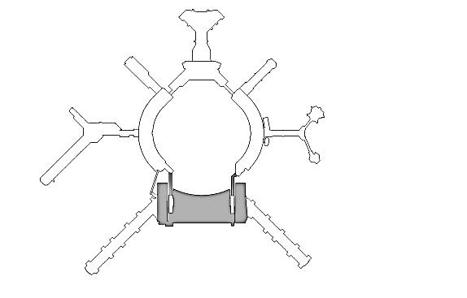

I

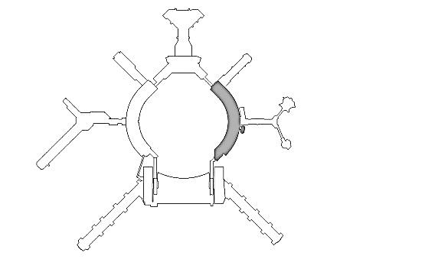

T1

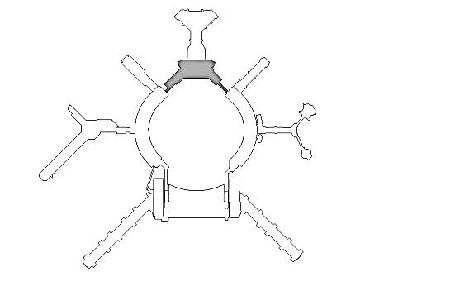

T2

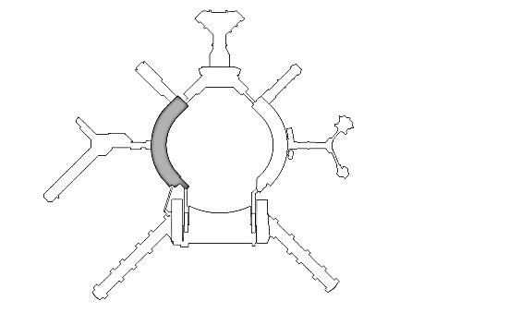

T3

Diagram 1 (Terminals)

Diagram 2 (Boarding Areas)

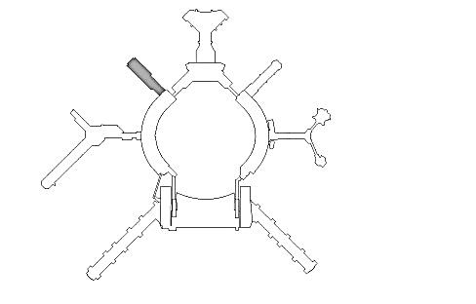

E

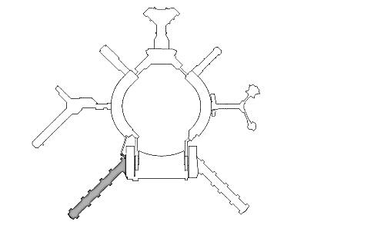

G

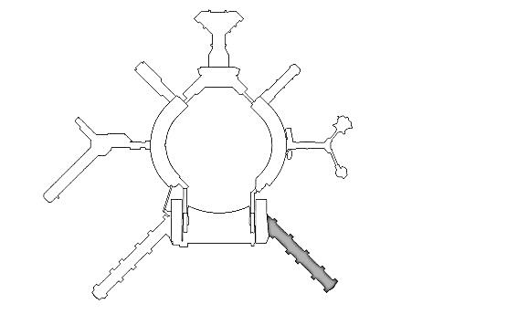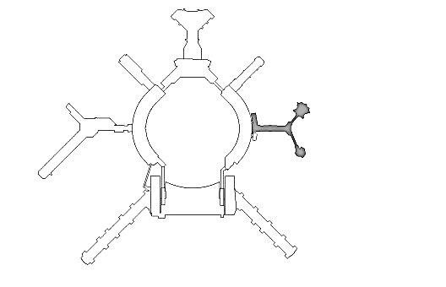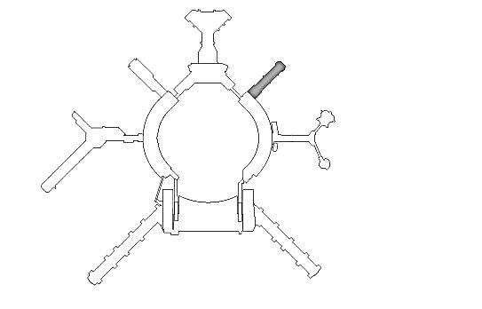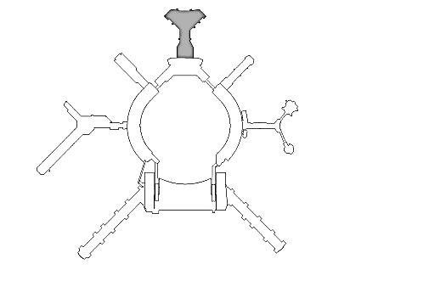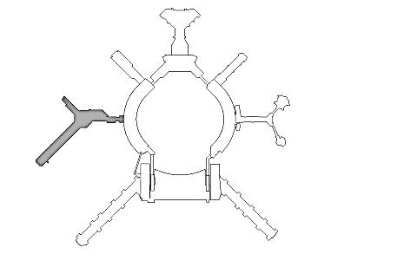

F

C

D

B

A

* 1. **Floor Level Designation:** Main Levels: The Airport has designated each building level with a Floor Level Code (FLC). Whole levels are numbered using a digit standard starting with ‘1’ for the first floor and continue up for every floor above (e.g., ‘2’=second floor, ‘3’=third floor). Levels may be referred to as ‘arrival’ and ‘departure’, but for purposes of formal naming and recording, levels will be known by the 1-digit FLC standard. If a space exists outside or (in special circumstance) independent of a structure, and is at ground level, it shall assume a FLC of ‘1’. Trailers and storage boxes that sit at ground level shall assume a FLC of ‘1’.
     + 1. **Special Cases**: In the event that a space spans between building levels, that space shall adopt the highest level which it serves. Example: A pedestrian walkway which spans from level 3 of the international terminal building to Level 2 of Terminal 3. In this scenario, the entire walkway space will be known as a Level 3 space from one end to the other. The adjoining or adjacent spaces on Level 2 shall remain as Level 2 spaces.
     1. **Basements, Sub-Basements, Tunnels, Utilidor**: Levels beneath Level 1 are designated as basement or sub-basement levels. Basements will be designated a FLC of ‘B’ and sub-basements will be designated by ‘B1’ and will continue down for every level below. Tunnels and Utilidor spaces should be considered as part of the basement level(s). (e.g. ‘B2’, ‘B3’, ‘B’4).
     2. **Mezzanines:** Mezzanine levels will assume a ‘M’ suffix, preceded by the Level number of the level it is directly above. Example: A mezzanine level directly above Level 1 will be ‘1M’, above Level 2 will be ‘2M’). If a mezzanine level does not have an entire level below, but rather another mezzanine level, or multiple levels or mezzanines on top of each other, then the first mezzanine will set the level number and continue in an ascending fashion for each consecutive mezzanine above. Example: If the first mezzanine starts at Level 2, then it will be called ‘2M’, then the next mezzanine as ‘3M’, ‘4M’, etc.).
     3. **Roof Levels:** Roof top levels will be designated by the letter ‘R’ and all roof spaces above the ‘R’ level will be designated by ‘R1’ and continue up for every level above. Example: ‘R’, ‘R2’, ‘R3’, etc.. For structures with multiple roofs at multiple elevations, the lowest roof shall be designated “R” and subsequent roofs, based on ascending elevation, will be named “R2”, “R3”, and so on in a similar, ascending fashion. Any roofs sharing the same elevation on a structure, even if not connected or related otherwise, shall share the same naming designation.

Penthouse Level

Roof Level (see Diagram 4)

4th Level (with balcony)

3rd Level (partial span example)

Mezzanine Level

2nd Level

1st Level

Basement Level

Sub-Basement Level 1

Sub-Basement Level 2

B2

2M

B

B1

1

2

3

4

R

P

Ground



Diagram 3 (Floor Level)

## 

Diagram 4 (Roof Level)



Ground

Roof

Roof



R

R1

R2

R3

Roof

Roof

## Space Numbering

* + - * 1. **General Space Numbering**: Spaces, unless a special condition exists, shall be numbered in the following order: Building Number, Floor Level, Space number. For terminal and boarding area spaces, the building number or name will be replaced by the building name. All other Airport structures will use building number.

Examples:

1. Terminal 1, Level 2, Room 106 = **T1.2.106**
2. Boarding Area D, Level 1, Room 320 = **D.1.320**
3. Building 575, 2nd floor Mezzanine, Room 202 = **575.2M.202**
   * + - 1. Methodology:

1. **Terminals and Boarding Areas:** (The methods in this section shall only be used within the terminal and boarding spaces). In terminals and boarding areas, the space numbers will ascend as spaces move away in a perpendicular fashion, from the curb at the International Upper and Lower Loop Roads and Domestic Upper and Lower Loop Roads.

2. Ascending Numbers and Zones:

* + - 1. Spaces numbers 000 – 99 are reserved for parking structures spaces only.
      2. Spaces numbered 100 – 199 are reserved for terminal spaces only.
      3. Space numbers greater than 200 shall be used in the boarding area spaces.

Diagram 5 (Ascending Numbers)

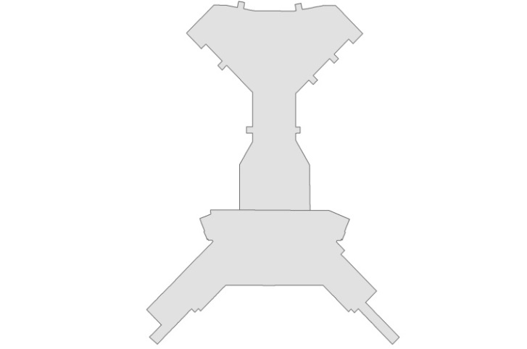

Curb

Space numbers increase with distance from curb.

Diagram 6 (Zones)

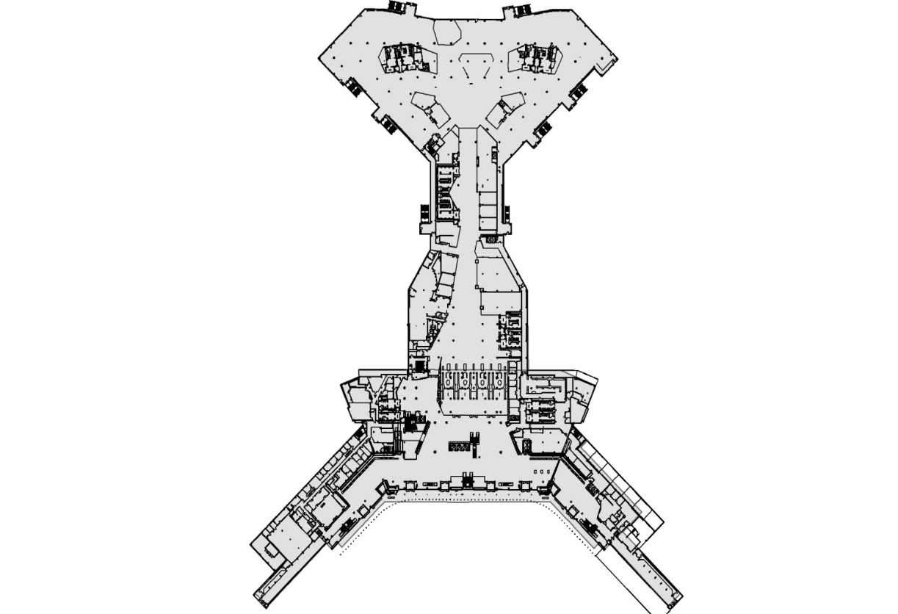

Zone 300

Zone 200

Zone 100

Space numbers 100-199

Space numbers 200 - 299

Space numbers 300 - 399

Terminal

Boarding Area

Diagram 6 (Note):

Terminal and boarding areas are to be divided into numeric zones. These zones will help users to determine where the room number will be located within the building. Space numbers are assigned within a zone and range from the lowest number in that zone to the highest. Zones will be in increments of 100 and will start with Zone ‘000’ up to Zone ‘300’ and higher if needed. Zone ‘100’ will be closest to the terminal curb-side and Zone ‘300’ or higher will be furthest from the curb-side, thus supporting the space numbers increasing in value away from the curb from Section 5.b.i.1. Zone breaks will be attempted to be performed at prominent architectural features of the structure. The Airport will make the determination of zone boundaries on a per terminal/boarding area basis.

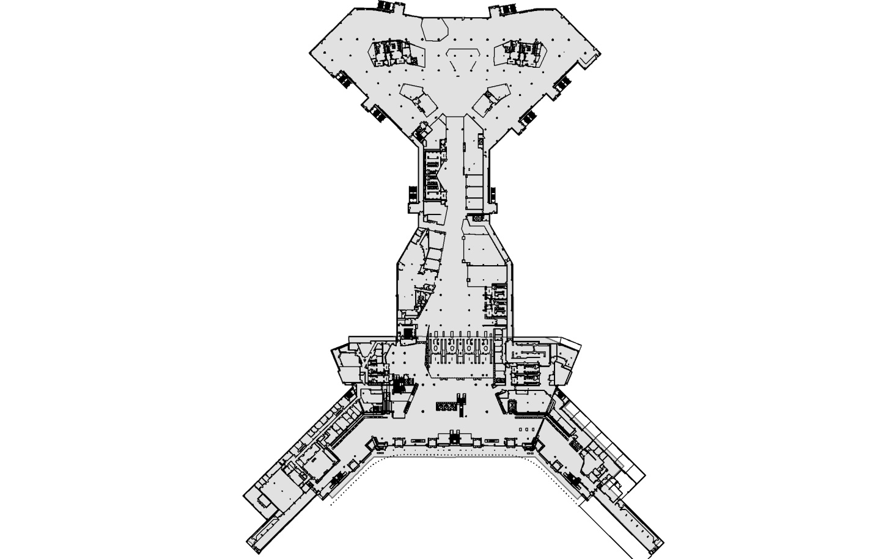

Even numbers

Odd numbers

Bisecting line

Diagram 7 (Space Numbering Sequencing)

Diagram 7 (Note):

If the boarding area shape and room configuration allows, it is recommended that the building is bisected along its length or similar such that the boarding area spaces can be numbered in an even and odd fashion, within reason. A boarding area division should take place along its longest or main corridor. From the curb-side, facing the building, those spaces on the right side of the boarding area shall be even numbers and those on the left shall be odd. Within the terminal spaces, it is advised that if a corridor exists, space numbers shall be coordinated with even numbers on one side, odd on the other. In more complex building design, or where the availability of numbers is limited, the even-odd format may be abandoned if consecutive numbering results in a more logical scheme.

* + 1. Non-Terminal and Non-Boarding Area Buildings:
       1. **Numbering Logic:** Space numbers should flow from one end of a building to another in an ascending fashion. In single corridor buildings, this can be achieved with relative ease.
       2. **Even/Odd Space Numbering Configuration**: As within the terminal and boarding areas, Airport buildings should all attempt to use the even and odd numbering concept when practical. Space numbers shall be coordinated such that even numbers are on one side of a corridor and odd numbers on the other. This format may be abandoned if consecutive numbering results in a more logical scheme due to building complexity or configuration.
       3. **Zones and ascending numbering formats:** Do not apply for non-terminal and non-boarding area buildings.
  1. **Interval Spacing of Numbers:** All Airport buildings will feature an interval space numbering scheme. The interval between space numbers is determined by making a space count and then dividing 100 by that number. Suites will be counted as one space. A skip interval of at least two is required; therefore a zone must be comprised of at least 50 spaces. Example: When 50 rooms are counted within a zone, the spacing interval will be 100/50 = 2. In this example, adjacent space numbers in Terminal 3, Level 1 would be assigned as T3.1.1, T3.1.5, T3.1.7, and so on). Space numbering at this phase must remain flexible and thus the use of interval spacing. Spaces assigned in an interval pattern can allow for future infill numbers, changes during construction and changes over the building life cycle.
     1. **Subdivision of spaces:** For any Airport building, each subdivided space will assume the primary space number, which will be suffixed by an alpha designator starting with ‘A’, ‘B’, and so on. If possible, the alpha designations should follow a counter-clockwise route around the primary space, which will help keep spaces in a contiguous alphabetic order. For sub-divided spaces that feature a lobby, this space will assume the primary space number with adjoining spaces to which the lobby serves as an entry named as ‘A’, ‘B’, ‘C’, etc. accordingly. A space subdivision suffix can be appended to the space ID without the use of a separator or “.”. Kiosks and pop-up type spaces within the terminals can assume the space number of the circulation space which it occupies. If the alphabet is exhausted, the convention can then move to a double alpha format such as ‘AA’, ‘BB”, and so on. All spaces at the Airport, regardless of location or type will be assigned one number or name. Even when a larger space is sub-divided, the new interior rooms will feature a unique ID by use of an alphabetic suffix. All accessible spaces will be numbered. Spaces that a person can access and move about or store items shall be considered. A space number shall be assigned regardless of physical marking and/or door placards. All spaces will be numbered and stored within the appropriate Airport’s databases, among other data.
  2. **Alternative Numbering Sequence:** If a building or space layout is arranged in an unconventional manner or in a design that does not suit the methodology put forth in this document then an alternative numbering sequence can be applied. In an alternative sequence the numbering convention still must be applied but the spatial methodology may be abandoned. In such cases, space numbering should be adjusted to support the function, configuration and/or general human traffic patterns of the space or building. The methodology then must be applied consistently for the remainder of the building. There should not be more than one methodology per building. SFO will, by committee, review any alternative numbering sequence requests.

## Building Support Items and Other Assets Numbering

a. Permanent Building Assets:

**Building Support Items:** Include, but are not limited to escalators, elevators, electric walkways, mechanical rooms, and electric rooms. These items are permanent, are to be considered as spaces and should be numbered as such. In existing buildings, these spaces may not follow the aforementioned space numbering methodology as they were pre-designated prior to the implementation of this convention. For all new buildings, the methodology set-forth in this document shall be used for these space types.

All permanent assets of this type shall be numbered uniquely. Support item numbering will use the standard building number and floor code designation along with the Asset Type Code (ATC) or Asset ID (AID). Asset type code and Asset ID will be concatenated as a prefix to the space number with no decimal point or space in-between.

Examples:

* + - 1. Asset Type Codes:
         1. Baggage Claim Carousel = ‘C’ (e.g.: **T2.1.C106**)
         2. Baggage Make-Up Area = ‘MU’ (e.g.: **T1.1.MU56**)
         3. Baggage Tunnel = ‘BT’ (e.g.: **T2.2.BT46**)
         4. Boarding Bridge = ‘BB’ (e.g.: **T3.2.BB78**)
         5. Check Point = ‘CP’ (e.g.: **B.2.CP12**)
         6. Crawl Space CS (e.g.: **T1.1.CS101**)
         7. Escalator = ‘ES’ (e.g.: **T2.2.ES613**)
         8. Elevator = ‘EL’ (e.g.: **T3.2.EL207**)
         9. Electric Walkway = ‘EW’ (e.g.: **T1.1.EW156**)
         10. Electrical Room = ‘E’ (e.g.: **676.1.E332**)
         11. Gate Hold Room = ‘HR’ (e.g.: **A.3.HR40**)
         12. Gate House = ‘GH’ (e.g.: **T2.2.GH50**)
         13. Mechanical Room = ‘M’ (e.g.: **T1.1.M456**)
         14. Stairway = ‘ST’ (e.g.: **575.4.ST12**)
         15. Vestibule = ‘V’ (e.g.: **T1.2.V101**)
         16. Utility Tunnel = ‘UT’ (e.g.: **T3.B.UT65**)
         17. Tunnel = ‘T’ (e.g.: **T1.B.T106**)
      2. Special Room Space Types:
         1. **Electrical rooms** are understood to include, but not limited to: Airport electrical rooms, tenant wiring closets, and special systems rooms.
         2. **Mechanical rooms** are understood to contain, but not limited to: HVAC components, pump rooms, plumbing chases, and all inaccessible vertical shafts for utilities.
         3. **Service elevators and lifts** located inside of a building should be included in the number sequence. Accessibility or loading dock lifts located outside the walls of the building should not be included.
         4. **Tenant Wiring Closets** (TWC) and Special Services Rooms (SSR) will both be categorized as electrical spaces (E), not TWC or SSR.
         5. **Vestibule** is a small chamber or foyer leading into a larger space. It is encouraged to add the vestibule ‘V’ designation to these types of spaces.
         6. **Gate House** is the fixed area of a boarding area or terminal leading to the Boarding Bridge. If possible, a Gate House should be numbered similar to the gate it serves and within its associated numbering zone.
         7. **Boarding Bridges** are spaces that lead from the terminal to the aircraft. Boarding Bridges are not fixed structures and may be moved. If possible a Boarding Bridge should be numbered similar to the gate it serves.
         8. **Central Garage Tunnels** are tunnels that lead from the Central Garage structure to the terminal buildings. Central Garage tunnels will typically start at an elevator core within the garage structure and extend into the domestic terminal buildings. Central Garage tunnels and their spaces are to be considered part of the Central Garage up to the face of the terminal building. All Central Garage tunnel spaces will be formatted to reflect the Central Garage building number (195) immediately followed by the Central Garage zone where the tunnel originates from (A, B, C, D, E, F, or G). E.g.: 195B.1.126. See Diagram 8 for garage zones.

Diagram 8 (Garage Zones)

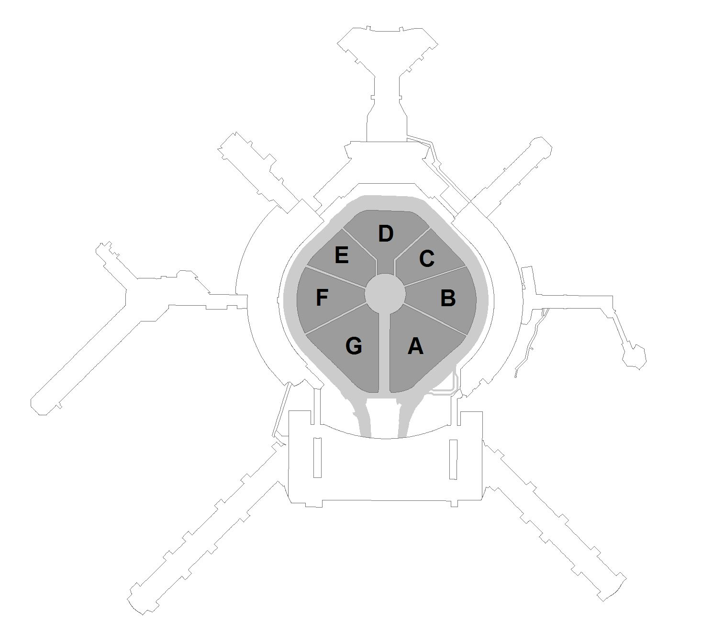

* + - 1. Vertical Penetrations:
         1. All vertical penetrations (stairs, elevator shafts, escalators), will have the same space number for each floor that they pass through.
         2. Stairs:

Stairs to designated by ST

Stairs are numbered ST-XX, where “X” is the stair number designation.

Stair landings and approach areas are to be named with the ‘ST’ designation.

Diagram 9 (Stairs and Landings)

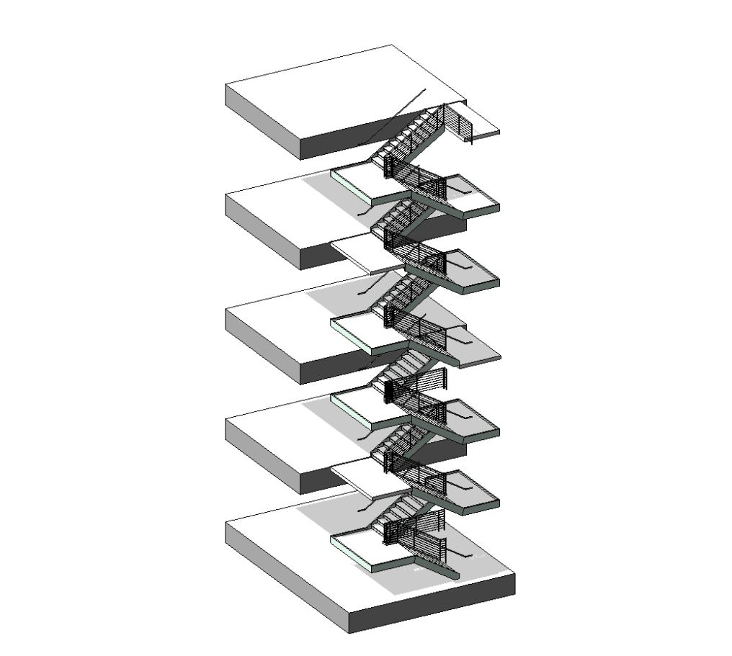

Level 3

Level 2

Level 1

Level 1 landings

Level 1 stairs

Level 2 stairs

Level 3 landings

## Do’s and Don’ts

* 1. Do:
     1. Do number all accessible spaces including corridors, lobbies, stairwells, closets, elevator shafts, etc.
     2. Do number all exterior covered unenclosed spaces, whether walled or not. These spaces are not always connected to a building.
     3. Do use an ascending numbering scheme when possible.
     4. Do use the even on one side and odd on another when in a building or corridor that permits this scheme.
     5. Do use spacing intervals to permit for future subdivision or growth.
     6. Do consider all accessible levels of a building as a level.
     7. Do use building name in the terminals and boarding areas.
     8. Do use building number in all non-terminal buildings.
     9. Do apply this document to any new spaces on the Airport campus.
  2. Don’ts:
     1. Do not number spaces one side of a hallway and back down the other side. Use the ascending number scheme.
     2. Do not leave an accessible space as un-numbered.
     3. Do not use hyphens, or space, or any other non-alphanumeric character other than the decimal point (“.”) in the space number.
     4. Do not use “arrivals” or “departures” as part of a space number.
     5. Do not renumber a space that has already been numbered.

## Conflicts and Special Cases

* 1. Suites:
     1. All suites and suite numbering are considered as special cases and will be designated by SFO AVM.
     2. Suite number(s) will not appear in the Airport space name, but can be used in the physical address or description of spaces.

## References

* 1. BIM: Please refer to the SFO BIM Guide
  2. CAD: Please refer to the SFO CAD Standard
  3. GIS: Please refer to the SFO GIS Standard

Chapter 2: Space Naming and Room Data Categorization

## Introduction

The purpose of this chapter is to define the San Francisco International Airport (SFO or Airport) Space Naming Standard and the related definitions of spaces within the airport. The Standard shall be utilized to ensure continuity of the Airport’s terminal and non-terminal spaces and to help maintain the integrity of the Airport’s spatial data infrastructure and design standards.

The Airport integrated spatial data scheme allows multiple databases and systems to be integrated through a common attribute. Since Computer Aided Design (CAD) drawings, Geographic Information System (GIS), and/or Building Information Modeling (BIM) serve as the basis for spatial geometry within these databases, it is imperative that drawings received from external sources follow the Standard so that data can be properly prepared for integration to the respective database program(s). In conjunction, the Airport has also adopted spatial data standards for CAD, GIS, and BIM to ensure compatibility in integrating new project drawings into the existing Airport’s data architecture.

## Definitions

1. **Occupant Class**: The most general designation of the use classification of a space type. This designation should be found in schedules and is used in the GIS platform for understanding the classification of the occupant of any given space. This information may change over the life of a space and may not be readily available during design and construction. Where attributes are used in the generation of project documentation, the attribute will be SFO_OccupantClass. These categories will be limited to:
   1. **Airline Leasable | Cat I**
   2. **Airline Leasable | Cat II**
   3. **Airline Leasable | Cat III**
   4. **Airline Leasable | Cat IV**
   5. **Airline Leasable | Cat V**
   6. **Airline Leasable | Other**
   7. **Airport**
   8. **Concession | Cat I**
   9. **Concession | Cat 2**
   10. **Concession | Cat 3**
   11. **Concession | Cat 4**
   12. **Concession | Other**
   13. **Government**
   14. **Unassigned**
2. **Occupant Department**: This classification designates the organization using or responsible for a particular space. This designation should be found in schedules and is used in the GIS platform and downstream applications at many departments for understanding leaseholder information, responsibilities and other operational considerations. This information may change over the life of a space and may not be readily available during design and construction. Where attributes are used in the generation of project documentation, the attribute will be SFO_OccupantDepartment. These categories include but may not be limited to:
   1. Airport – *(spaces managed by SFO)* – Use specific departments below:
      1. **Administration and Policy**
      2. **Airport Commission**
      3. **Business and Finance**
      4. **External Affairs**
      5. **Operations**
      6. **Planning and Construction**
      7. **Vacant**
   2. **Federal – *(spaces occupied by the federal government or it’s agencies)***
   3. **State – *(spaces occupied by the state of California or it’s agencies)***
   4. **Local – *(spaces occupied by any specific city or county or their respective agencies)***
   5. **Tenant *– (actual tenant or concessionaire leasing space from the airport)***
   6. **Other – *(spaces occupied by an organization other than those listed above)***
   7. **Vacant – *(spaces currently unused or unoccupied)***
3. **SFO Section**: This classification designates the organization within the SFO Airport Commission using or responsible for a particular space. This designation should be found in schedules and is used in the GIS platform and downstream applications at many departments for understanding leaseholder information, responsibilities and other operational considerations. This information may change over the life of a space and may not be readily available during design and construction. Where attributes are used in the generation of project documentation, the attribute will be SFO_Section. These categories include but may not be limited to:
   1. **Accounting**
   2. **Airport Commission**
   3. **Airport Services**
   4. **Architectural Services**
   5. **Aviation & Parking Management**
   6. **Communications**
   7. **Engineering & Construction Services**
   8. **Environmental Policy & Sustainability**
   9. **Facilities**
   10. **Finance**
   11. **General Council**
   12. **Governmental Affairs**
   13. **Guest Services**
   14. **Hotel Development & Special Services**
   15. **Information Technology and Telecommunications**
   16. **Infrastructure Information Management**
   17. **International Marketing & Aviation Development**
   18. **International Trade & Commerce**
   19. **Marketing**
   20. **Museum**
   21. **Noise Abatement**
   22. **People, Performance & Management**
   23. **Planning and Environmental Affairs**
   24. **Project Management**
   25. **Protocol / Economic Liaison**
   26. **Reprographics**
   27. **Revenue Development & Management**
   28. **Safety & Security**
   29. **SFFD**
   30. **SFO Medical Clinic**
   31. **SFPD**
   32. **Social Responsibility & Community Stability**
   33. **Strategic Programs**
   34. **Undifined**
   35. **Other**
4. **Use**: This classification describes the general purpose of the space. This designation should be found in schedules and is used to understand the purpose or intended use of a space. It is used during design and construction for planning purposes and understanding the adjacencies of spaces. Where attributes are used in the generation of project documentation, the attribute will be SFO_Use. For spaces that support building systems, the system will be the use. Uses will be limited to:
   1. **Baggage Handling**
   2. **Circulation**
   3. **Communications**
   4. **Electrical**
   5. **Exhibition**
   6. **Fire/Life Safety**
   7. **Food and Beverage**
   8. **Hold Room**
   9. **Lounge**
   10. **Maintenance**
   11. **Mechanical**
   12. **Office**
   13. **Parking**
   14. **Plumbing**
   15. **Restrooms**
   16. **Retail**
   17. **Security**
   18. **Special Systems**
   19. **Specialty Functions**
   20. **Storage**
   21. **Other**
   22. **Vacant**
5. **Description:** The description of the space provides greater specificity than the general use. It designates the specific function of the space inclusive of numerical or unique functional attributes such as the number of a baggage carousel or even an item occupying a space such as a large mechanical unit, moving walkway or other significant space occupying element. The table below contains approved description titles, but additional descriptors may be needed for specific projects and may be requested. Where attributes are used in the generation of project documentation, the attribute will be SFO_SpaceDescription.
6. **Space Name**: The name for the space on project plans, other outward facing documentation used during design and construction. This name is for clarity on diagrams and documentation. It generally will match the description above but may include elements of Occupant class, Occupant, or Use as defined above. Approved space names are in the table below, but additional space names may be needed for specific projects and may be requested. Where attributes are used in the generation of project documentation, the attribute will be SFO_SpaceName.
7. **Security Class**: The airport is separated into multiple layers of security. Every space within the airport is classified by the level of security maintained within that area. The adjacencies of two different security zones needs to be fully understood in order to facilitate security services. Every space therefore needs to have an associated security class. Where attributes are used in the generation of project documentation, the attribute will be SFO_SecurityClass. The security classes are defined as follows:
   1. **Pre-Security**
   2. **Post-Security I**
   3. **Post-Security II**
   4. **Post-Security III**
   5. **Post-Security IV**
8. **Public Access Class**: This classification is generally a binary setting for public accessibility. All spaces are either public access or limited access. Limited access indicates restrictions based on any status which would prohibit a person from entering the space other than security screening of passengers. The primary screening factor is whether an individual is required to wear an SFO badge or needs to be accompanied with someone with an SFO badge. Areas where access is intermittently available to people without a badge are considered Alternating. An example of a space meeting this criterion is a boarding bridge which is open to passengers during boarding and deplaning but restricted at all other times. Where attributes are used in the generation of project documentation, the attribute will be SFO_PublicAccess. This a binary attribution:
   1. **Public**
   2. **Private**
   3. **Alternating**

## Space Naming Table

| **Use** | **Description** | **Space Name** |
| --- | --- | --- |
|  |  |  |
| Baggage Handling | Baggage Elevator | BHS Elevator |
|  | Baggage Tunnel | BHS Tunnel |
|  | BHS Access | BHS Access |
|  | BHS Bag Lift Control | Bag Lift Control |
|  | BHS Carousel | BHS Carousel |
|  | BHS Checked Baggage Inspection System | Checked Baggage Inspection System |
|  | BHS Control | Reinduction |
|  | BHS Conveyor | BHS Conveyor |
|  | BHS Makeup | Baggage Makeup |
|  | BHS Spare Parts and Storage | BHS Spare Parts and Storage |
|  | BHS Workshop | BHS Workshop |
|  | Early Bag Storage | Early Bag Storage |
|  | Lift Access | BHS Lift Access |
|  | Oversized Baggage Pickup | Oversized Baggage Pickup |
|  | Oversized Vestibule | Oversized Vestibule |
|  | Reinduction | Reinduction |
|  |  |  |
| Circulation | Basement Access | Basement Access |
|  | Corridor | Corridor |
|  | Delivery Ramp | Delivery Ramp |
|  | Electric Walkway | Electric Walkway |
|  | Elevator | Elevator |
|  | Escalator | Escalator |
|  | Exit Passageway | Exit Passageway |
|  | Lobby | Lobby |
|  | Pet Relief | Pet Relief |
|  | Ramp | Ramp |
|  | Roof Access | Roof Access |
|  | Stair | Stair |
|  | Train Platform | Train Platform |
|  | Tunnel | Tunnel |
|  | Vestibule | Vestibule |
|  |  |  |
| Communication | Cellular DAS | Cellular DAS |
|  | Communications | Communications |
|  | Fiber Room | Fiber Room |
|  | Internet | Internet |
|  | Radio | Radio |
|  | Telecom | Telecom |
|  |  |  |
| Electrical | Branch | Electrical Branch |
|  | Conduit Pathway | Conduit Pathway |
|  | Electric Meter | Electric Meter |
|  | Electrical | Electrical |
|  | Emergency Power | Emergency Power |
|  | Generator | Generator |
|  | Ground Power Unit | GPU |
|  | Load Center | Load Center |
|  | Metering | Metering |
|  | Security | Security |
|  | Solid State Relay Room | SSR |
|  | Substation | Substation |
|  | Tenant Electric Meter | Tenant Electric Meter |
|  | Tenant Wiring Closet | TWC |
|  |  |  |
| Exhibition | Architectural Library | Architectural Library |
|  | Gallery Space | Gallery |
|  | Exhibit Space | Exhibit |
|  | Exhibit Case | Exhibit Case |
|  | Library | Library |
|  | Zone Closet | Zone Closet |
|  |  |  |
| Fire/Life Safety | Fire Control Room | Fire Control Room |
|  |  |  |
| Food and Beverage | Dining Area | Dining |
|  | Freezer | Freezer |
|  | Kitchen | Kitchen |
|  | Refrigerator | Refrigerator |
|  | Service Area | Service |
|  | Tray Wash | Tray Wash |
|  | Tap Room | Tap Room |
|  |  |  |
| Hold Room | Gate House | Gate House |
|  | Gate House Mezzanine | Gate House Mezzanine |
|  | Gate House Vestibule | Gate House Vestibule |
|  | Gate Waiting Area | Hold Room |
|  | Passenger Boarding Bridge | Passenger Boarding Bridge |
|  |  |  |
| Lounge | Airline Lounge | Airline Lounge |
|  | Break Room | Break Room |
|  | Fitness Room | Fitness Room |
|  | Kid's Spot | Kid’s Spot |
|  | Lobby | Lounge Lobby |
|  | Generic or Unassigned Lounge | Lounge |
|  | Private | Private Lounge |
|  | Reflection Center | Reflection Center |
|  | United Service Organization | USO |
|  | Yoga Room | Yoga Room |
|  | Zen Room | Zen Room |
|  | Zumba Room | Zumba Room |
|  |  |  |
| Maintenance | A/C Paint Shop | A/C Paint Shop |
|  | Auto Paint Shop | Auto Paint Shop |
|  | Auto Shop | Auto Shop |  |
|  | Battery Shop | Battery Shop |
|  | Carpenter | Carpenter |  |
|  | Cleaning | Cleaning |  |
|  | Electric Shop | Electric Shop |
|  | Elevator Shop | Elevator Shop |
|  | Fleet Services | Fleet Services |
|  | Lock Shop | Lock Shop |  |
|  | Maintenance | Maintenance |
|  | Mud Room | Mud Room |  |
|  | Oxygen Shop | Oxygen Shop |
|  | Paint Shop | Paint Shop |  |
|  | Shop Booth | Shop Booth |  |
|  | Spray Room | Spray Room |  |
|  | Steam Fitter | Steam Fitter |
|  | Tech Room | Tech Room |  |
|  | Trash Room | Trash Room |  |
|  | Workshop | Workshop |  |
|  |  |  |
| Mechanical | Air Compressor | Air Compressor |
|  | Air Handling Unit | Air Handling Unit |
|  | Boiler Room | Boiler Room |
|  | Chiller Room | Chiller Room |
|  | Equipment | Mechanical Equipment |
|  | Exhaust | Exhaust |
|  | Fan | Fan |
|  | Filter | Filter |
|  | Gas Meter | Gas Meter |
|  | Grease Interceptor | Grease Interceptor |
|  | Hydrant Fuel Control | Hydrant Fuel Control |
|  | Mechanical Chase | Chase |
|  | Mechanical | Mechanical |
|  | Mechanical Opening | Mechanical Opening |
|  | Mechanical Shaft | Shaft |
|  | Penthouse | Penthouse |
|  | Preaction | Preaction |
|  | Pump | Pump |
|  | Tenant Gas Meter | Tenant Gas Meter |
|  |  |  |
| Office | Open Office Area | Open Office Area |
|  | Office | Office |
|  | Copy Room | Copy Room |
|  | Conference Room | Conference Room |
|  | File Storage | File Storage |
|  | Plan Room | Plan Room |
|  | CBP Ready Room | CBP Ready Room |
|  | Library | Library |
|  | Secretary | Secretary |
|  |  |  |
| Plumbing | Gas Meter | Gas Meter |
|  | Plumbing Access | Plumbing Access |
|  | Plumbing Chase | Plumbing Chase |
|  | Plumbing Meter | Plumbing Meter |
|  | Plumbing Valve | Plumbing Valve |
|  | Preaction | Preaction |
|  | Preaction Controls | Preaction Controls |
|  | Pump | Pump |
|  | Pump Room | Pump Room |
|  | Sewage Ejector | Sewage Ejector |
|  | Tenant Gas Meter | Tenant Gas Meter |
|  | Tenant Water Meter | Tenant Water Meter |
|  | Water Heater | Water Heater |
|  | Water Meter | Water Meter |
|  |  |  |
| Restrooms | Mens Restroom | Mens Restroom |
|  | All Gender | All Gender Restroom |
|  | Companion Care | Companion Care |
|  | Dressing Room | Dressing Room |
|  | Family Restroom | Family Restroom |
|  | Locker Room | Locker Room |
|  | Nursery | Nursery |
|  | Service Animal Relief Area | Service Animal Relief Area |
|  | Shower | Shower |
|  | Womens Restroom | Womens Restroom |
|  |  |  |
| Retail | ATM | ATM |
|  | Book Store | Book Store |
|  | Other Concession | Concession |
|  | Duty Free | Duty Free |
|  | Duty Free Pickup | Duty Free Pickup |
|  | Kiosk | Kiosk |
|  | News Stand | News Stand |
|  | Shoeshine | Shoeshine |
|  | Spa | Spa |
|  | Vending | Vending |
|  |  |  |
| Security | Employee Checkpoint | Employee Checkpoint |
|  | Outbound Search | Outbound Search |
|  | Post-Security | Post-Security |
|  | Pre-Security | Pre-Security |
|  | Public Checkpoint | Public Checkpoint |
|  | Recompose area | Recompose Area |
|  | Security Vestibule | Security Vestibule |
|  | TSA Precheck Control Point | TSA Precheck Control Point |
|  | TSA Private Screening | TSA Private Screening |
|  |  |  |
| Special Systems | Charging Stations (non-vehicular) | Charging Stations |
|  | Elevator Control | Elevator Control |
|  | Elevator Meter | Elevator Meter |
|  | Emergency | Emergency |
|  | Fire Command Center | Fire Command Center |
|  | Special Systems Chase | Special Systems Chase |
|  | Special Systems Emergency | Special Systems Emergency |
|  | Special Systems Preaction Controls | Special Systems Preaction Controls |
|  | Unit Load Device | Unit Load Device |
|  | Zone Closet | Zone Closet |
|  |  |  |
| Specialty Functions | Ticketing | Airline Ticketing |
|  | Curbside Check-in | Curbside Check-in |
|  | Material Recover | Material Recovery |
|  |  |  |
| Storage | Concession | Concession Storage |
|  | Custodial | Custodial Storage |
|  | Earthquake Locker(s) | Earthquake Locker(s) |
|  | Emergency Locker(s) | Emergency Locker(s) |
|  | Lift | Lift Storage |
|  | Miscellaneous | Miscellaneous Storage |
|  | Spare Parts | Spare Parts Storage |
|  | Stanchion | Stanchion Storage |
|  | Warehouse | Warehouse |
|  | Wheelchair | Airline Wheelchair Storage |
|  | Wheelchair | Vendor Wheelchair Storage |
|  | Window Washing | Window Washing |
|  |  |  |
| Vehicle Zone | Charging Stations – Vehicular Public | Charging Stations |
|  | Charging Station – Vehicular Restricted | Charging Stations |
|  | Charging Station – Ground Service Equipment | Ground Service Equipment Charging Stations |
|  | Ground Service Equipment Parking | Ground Service Equipment Parking |
|  | No Parking Zone | No Parking Zone |
|  | Parking | Parking |

Chapter 3: Door Numbering

## Introduction

The purpose of this section is to insure a common methodology around door numbering and identification. Door numbering must be standardized throughout the airport to facilitate the operations of security, emergency services, key shop and other airport functions. The basis of the door numbering standard is the building and space numbering standards as identified earlier in this document. The building, level and space numbers form the basis of the door number.

## Definitions

1. **Door Number**: The unique number given to a door to identify it for scheduling, maintenance, and operation by the airport.
2. **Door Tag:** For this standard we are referring to the physical tag supplied to the door for identification. It also allows a person in a space a quick visual check for the building, level and space number for the room they are in. This facilitates the ability for police, fire and emergency personal to locate the building, level and room for room information and response.

## Numbering Convention

The door numbering convention is a concatenation of locational information giving each door a unique number based on where it is located. The numbering is based on the following elements:

* Building Number
* Level Number
* Room Number
* Suffix for rooms with more than a single door

During design and construction, each element is separated by a decimal point. In all construction document schedules, models and drawings the decimal will be used.

For example, the copy room on the third floor of the Consolidated Administration Campus building would generate the door tag from the following information:

* Building Number: 674
* Level: 3
* Space Number: 111

The door number would therefore be 674.3.111.

For rooms which have multiple doors, the primary door gets the base number and subsequent doors are given an alpha suffix beginning with the letter A.

For example, conference room 2B on the second floor of the Consolidated Administration Campus building would generate door tags from the following information:

* Building Number: 674
* Level: 2
* Space Number 202

The first door number for the primary door would therefore be 674.2.202.

The second door number would therefore be 674.2.202.A

## Door Tags

Door Tag Material Description

* The door tag should follow the Airport Door Tag Material standard
* Sign fabricator to refer to architectural door schedule

Door Tag Size

* The door tag shall be 1” tall by 4” wide

Door Tag Color Combinations

* Field verify door frame conditions to determine appropriate sign color option
* Sign will be white w/black lettering
* Sign will be black w/white lettering

Number and Syntax

* Every door will have two (2) door tags, one mounted on the exterior and one mounted on the interior of the door frame.
* **Door numbers on the tags shall use dashes in place of decimals, as shown in the diagram below.**

T2-1-001

## Door Tag Placement

Door Tag Placement

For single doors, mount the door tag to the door frame on the latch side of the door.

For double doors, mount the door tag to the door frame in the middle for the double doors.

* Position door tag on the latch side of door frame
* Position on both sides of the frame (push and pull sides of the frame)
* Attach the door tag to door frame as shown below.



Appendix 1: Space Numbering Review and Approval Checklist

(INTERNAL USE ONLY):

Contract No. Contract Title:

🞎 Revit Process Delivery 🞎 Non-Revit Process Delivery

|  |  |  |  |
| --- | --- | --- | --- |
| RECEIVED | RECEIVED BY | EMAILED DATE | INITIAL |
| IIM |  |  |  |
| COMMITTEE | REVIEWED BY | COMPLETION DATE | INITIAL |
| BIT (Revit only) |  |  |  |
| - Live schedules |  |  |  |
| - Shared Parameters |  |  |  |
| - Bluebeam Session |  |  |  |
| GIS |  |  |  |
| AVM |  |  |  |
| RETURNED | RETURNED TO | APPROVAL DATE | INITIAL |
| IIM |  |  |  |

Appendix 2: Revit Alias Space Numbering Protocol

To facilitate the space numbering of buildings during design without prematurely encumbering the design team with numbering protocol, the Airport has developed an alias numbering system. This system allows project teams to use the room and door numbering parameters out of the box for developing their project documents and the execution of work in the field. In this way, changes to layout or function of spaces during the design process will not alter data associated with room numbers and door schedules.

As part of the BIM Integration Team’s (BIT) efforts, two alias parameters will be included in the shared parameter files distributed to all teams. These two parameters are:

* SFO_SpaceNumber
* SFO_DoorNumber

These two parameters will be added to room families and door families respectively. Floor plan’s room and door tags will contain two fields; the out of the box room (or door) number field and the SFO_SpaceNumber (or SFO_DoorNumber) field as illustrated below:

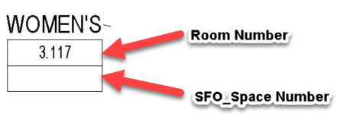 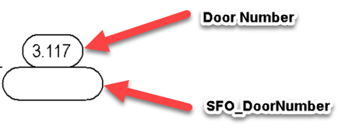

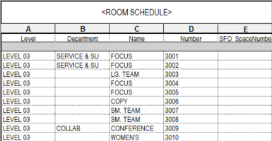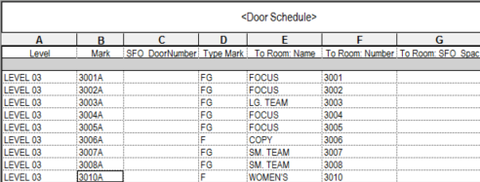Similarly, the SFO_SpaceNumber and SFO_DoorNumber parameters will be added to all schedules that contain the out of the box room and door number parameters as illustrated in the respective room and door schedules below.

During the normal course of design and construction these fields will remain blank.

The project team will be required to identify the point in time when certain ‘in place work’ will require the assignment of the final SFO space and door numbering. Examples of such requirements may be the issuance of a signage package, final location of mechanical equipment for operations and maintenance identification, and so forth. When the first of these milestones is identified, the project team needs to coordinate with the BIT to establish a submittal schedule of space numbering plans in PDF format for the Committee to assign final space numbering and door numbering. This shall be no less than four weeks to allow full vetting and assignment of the numbering schema.

Once the Committee has assigned and returned the space numbers to the project team, the project team will input the Airport numbering schema into the SFO_SpaceNumbering and SFO_DoorNumbering parameters in the project. This will in turn make every schedule a key between the design and construction numbering and the SFO numbering.

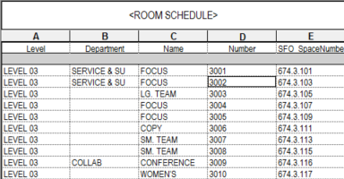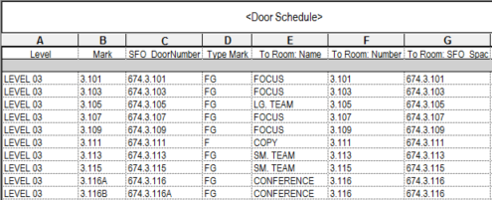

Likewise, by using the tags with duel parameters, the plan drawings become key drawings between the construction numbering schema and the SFO numbering schema.

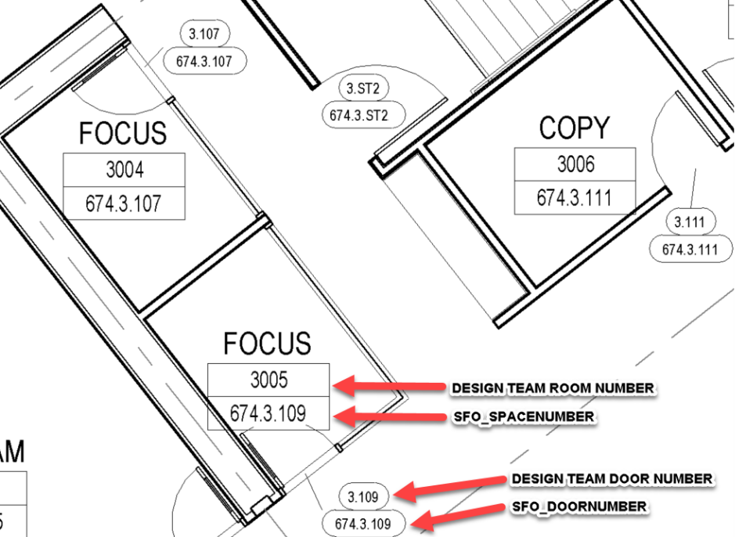

It is also permissible for project teams to use a key plan for the relationship between construction and operational space and door numbering. These drawings will be located in the G0 series of the sheet set.

The overall process diagram is as follows: